Project Report

Position control experiment prototype

Submitted by:

1. Mostafa Eliwa
2. Ahmed AlGhannam
3. Ahmed Nashaat

Supporting Faculty:

Dr. Mostafa Abdalla

# Introduction

This report shows the output of the proposed position control prototype project. Position control is a device that aims to demonstrate the basics of control theories and concepts through experiments.

The final setup was manufactured to be mounted on a housing which contains all the electronics. An arrow can be moved by a DC motor in a rotational motion to point to the desired angle. The rotational positioning is measured by an encoder and delivered as a voltage signal. The output signal from the sensor is sent to the software controller. The output signal from the controller influences the motor current. The motor is automatically shut down if the arrow reaches the end position using limit switch.

# Mechanical design

The prototype was made in a limited budget and resources, accordingly we used onshelf material like Acrylic. The acrylic is colored and looks shiny and clean so we avoid the painting process. We also used the resources available in the university like Laser cutter, soldering tools and glue gun. The overall cost of the housing was around 950 EGP including the wasted materials, transportation, design errors. The mechanical design and its production took around a week from the beginning to the delivery point to the electrical team.

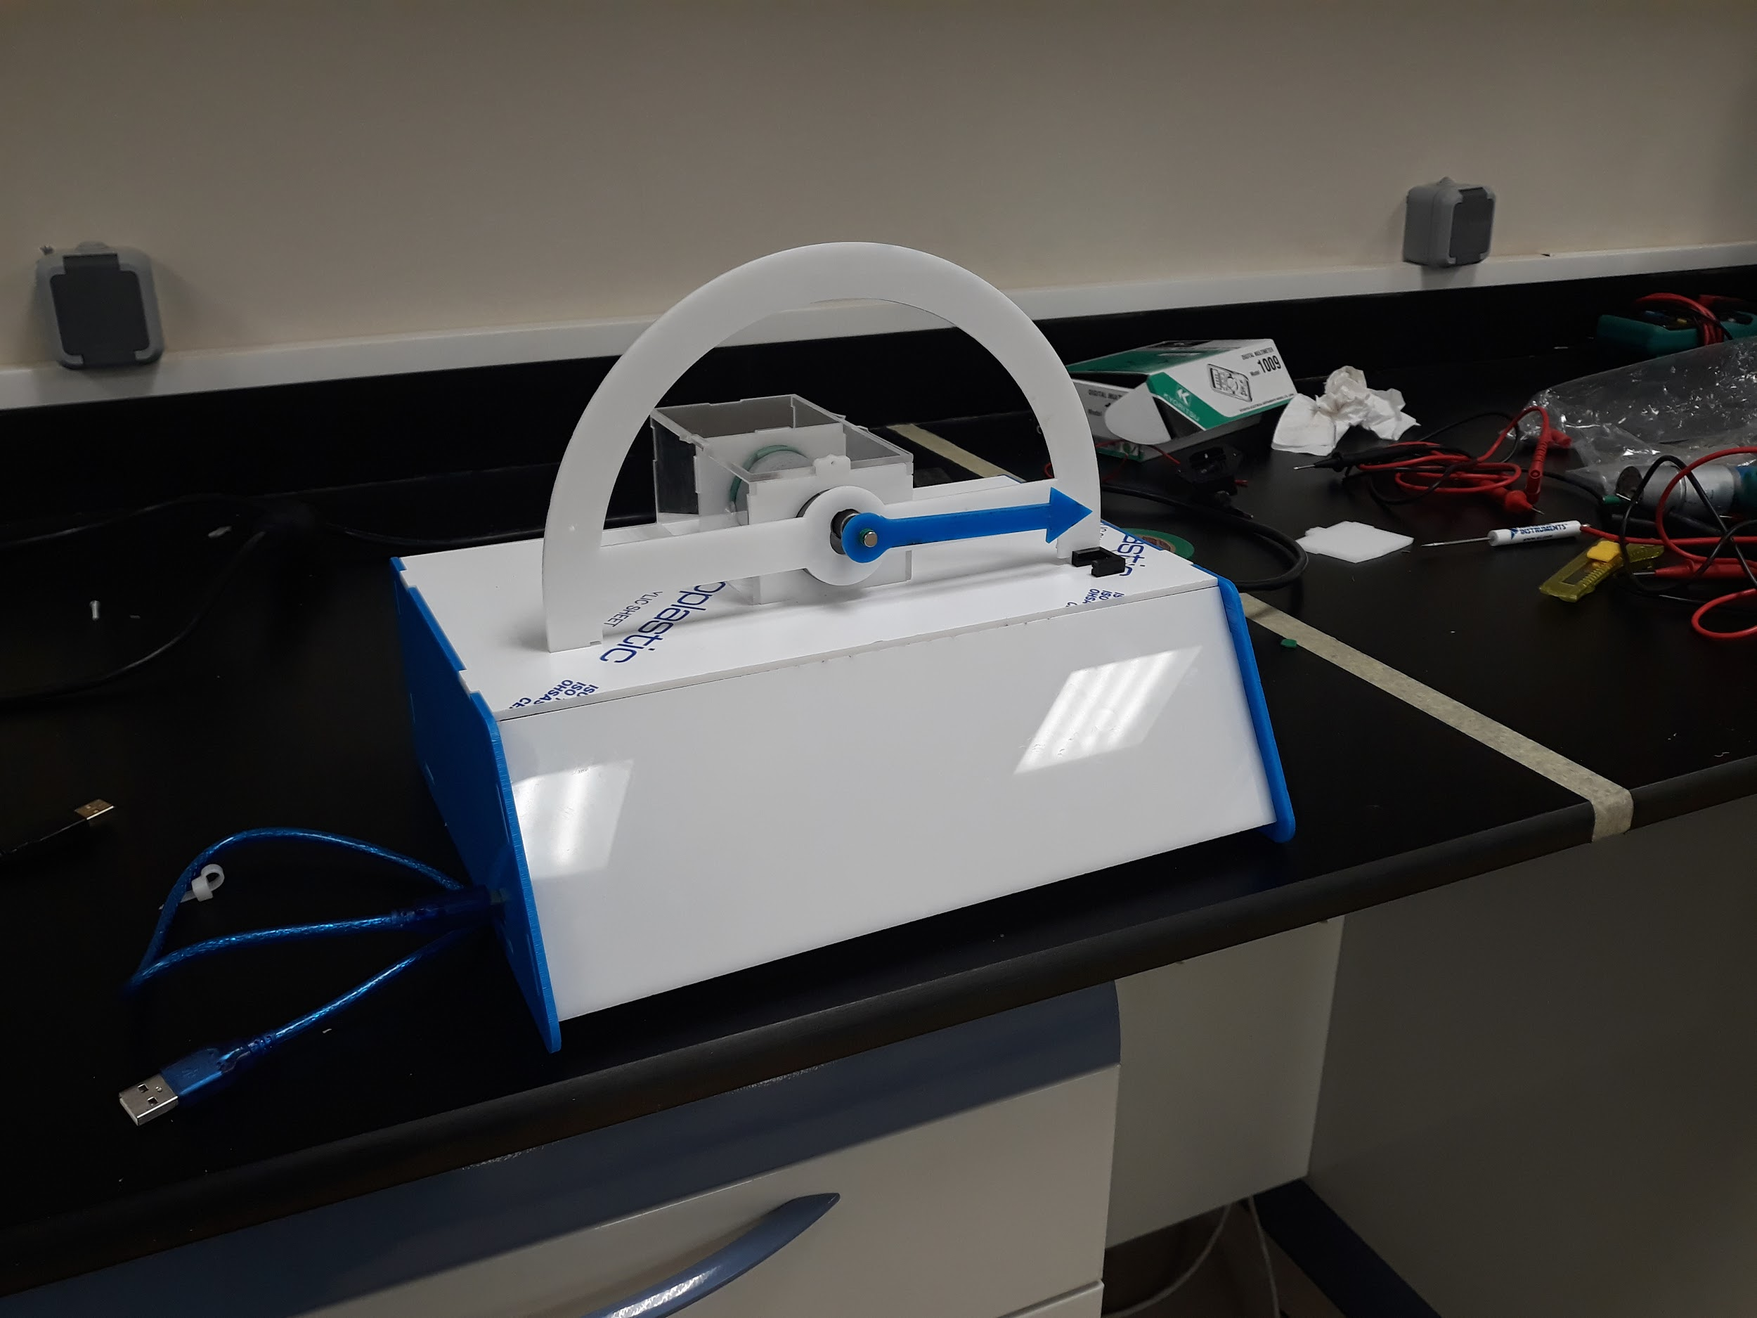

Figure 1: A view of the realised prototype.

# Electrical design

The electrical team purchased the component required for the experiment and installed it once the casing finished. The components includes a DC motor with encoder, motor driver, power supply, arduino, limit switch and wires. The electronics were tested and linked via usb cable for students to perform the experiments and control it using their laptops.

Figure 2: Views of the electric components of the set-up.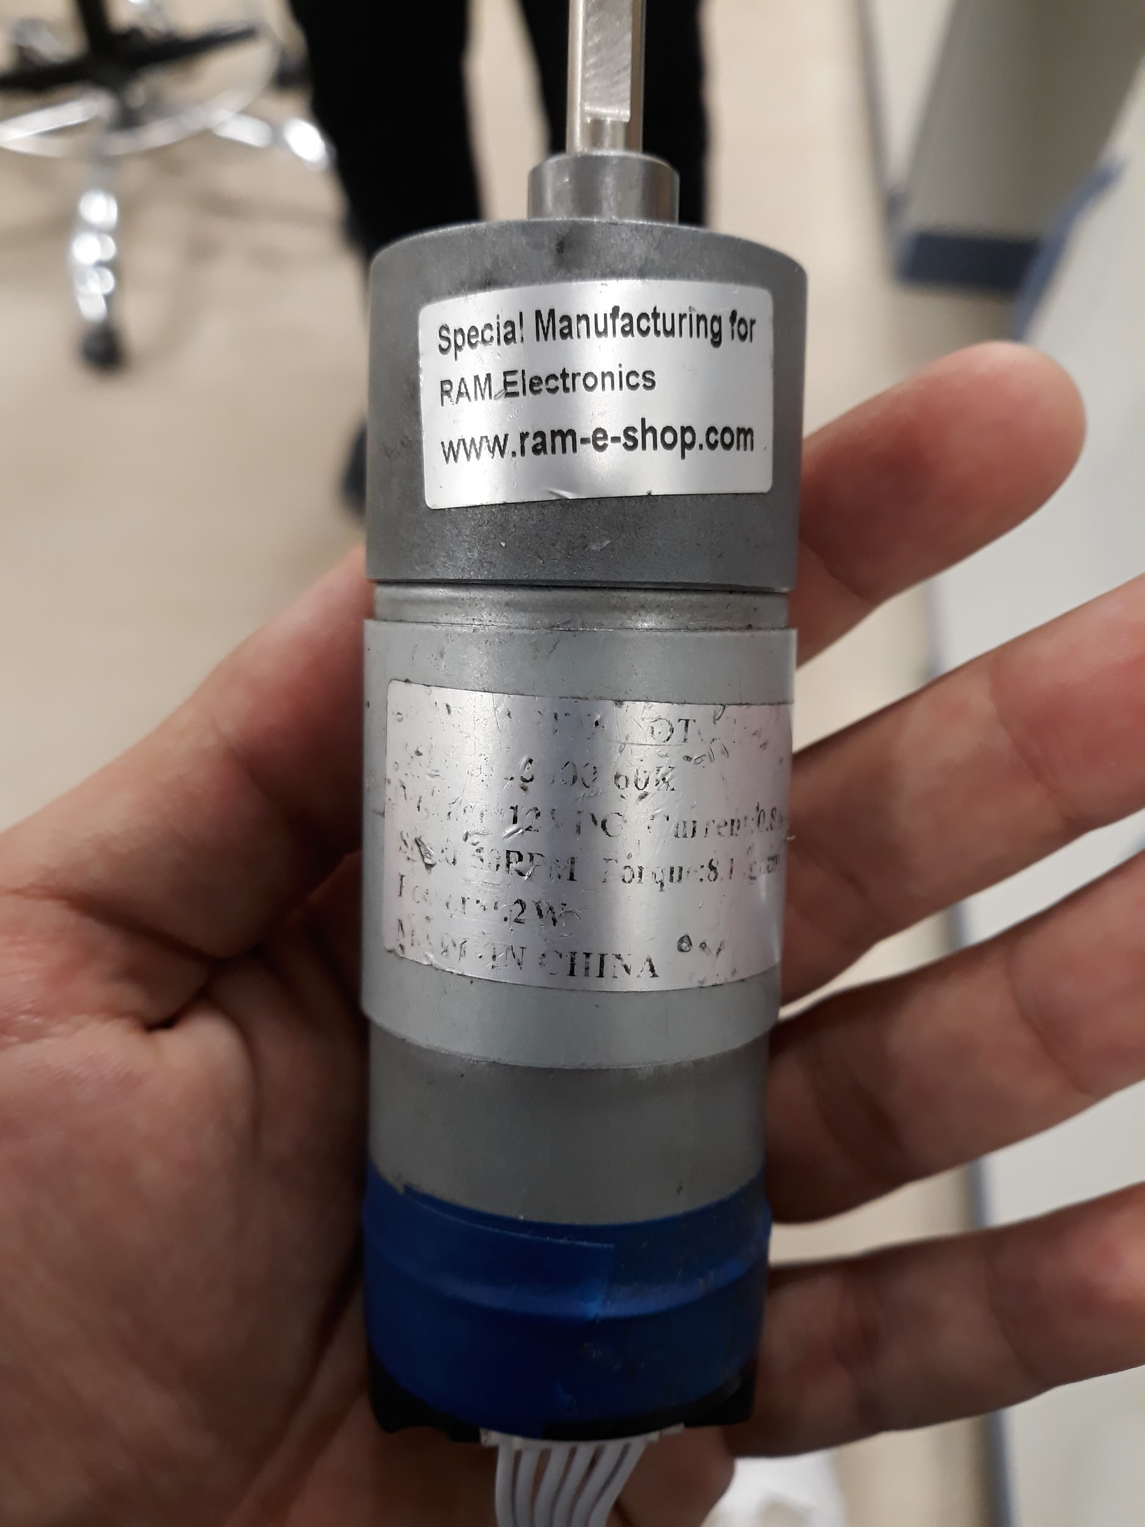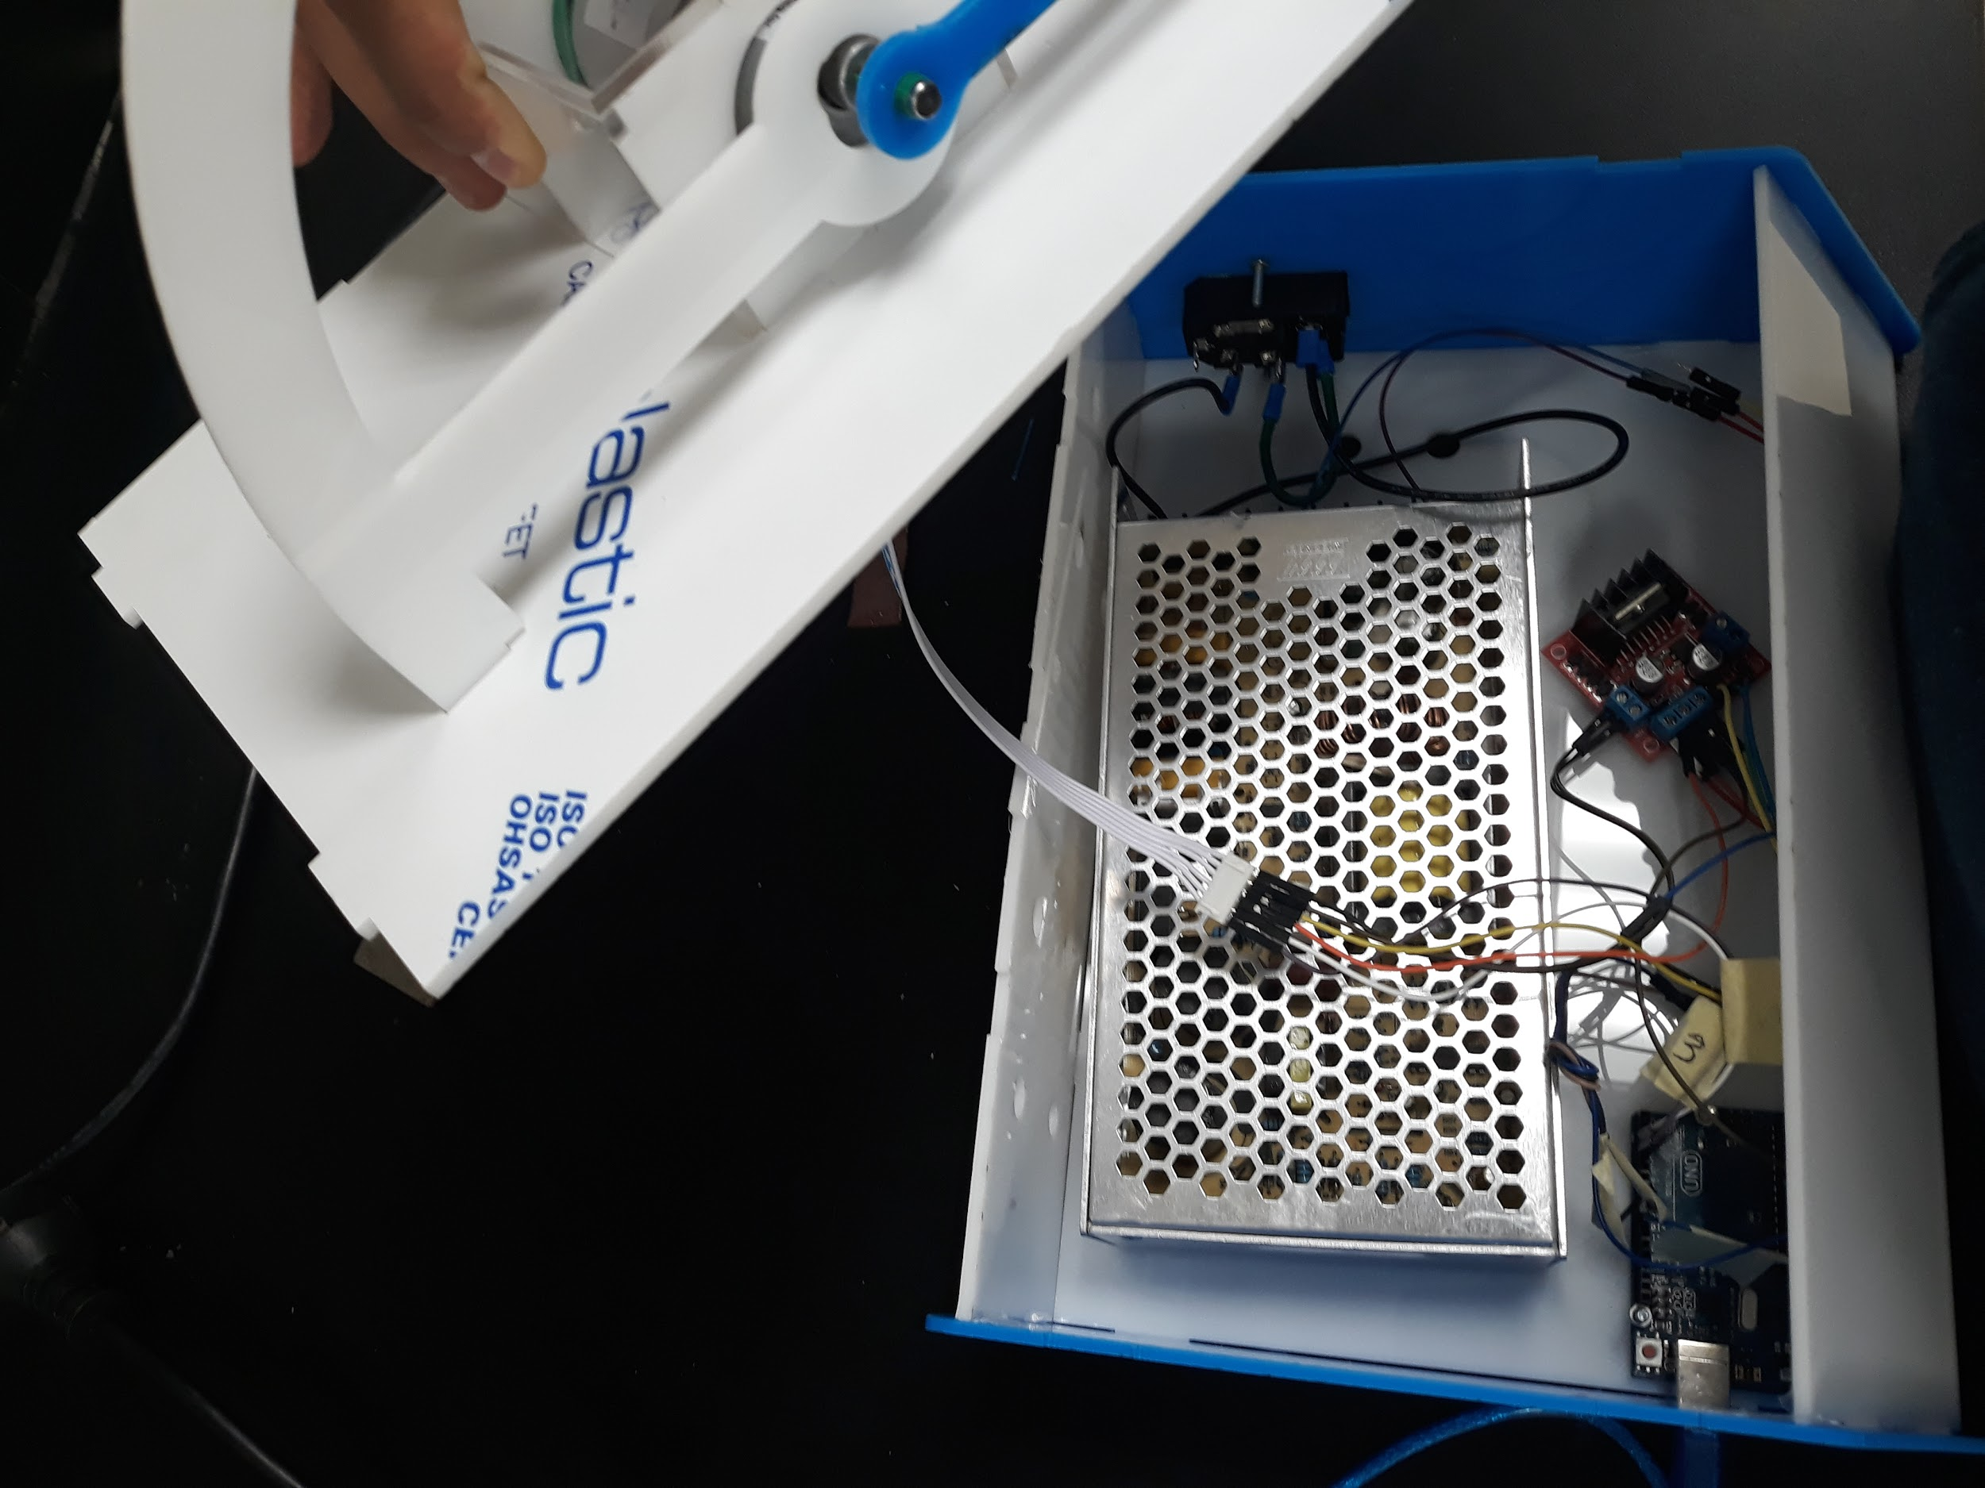

# Software

The software was designed using matlab for easy use by students. Student will plug the usb and open matlab then will find a GUI explaining how to use the device and how to conduct the experiments. Each experiment delivers a concept in control theories that already explained by professors in class.

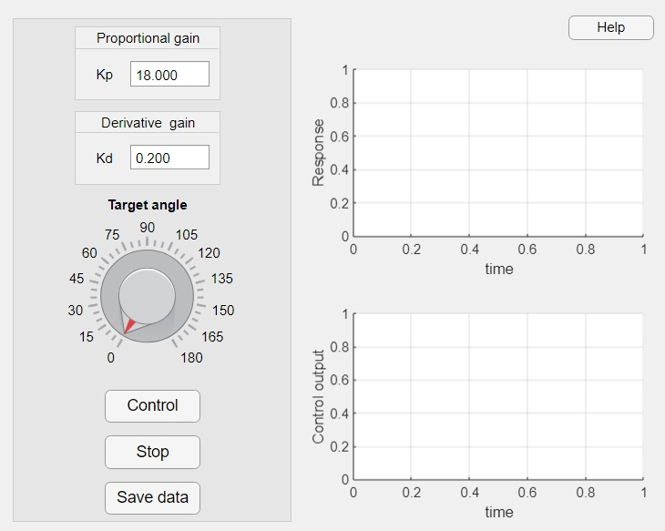

Figure 3: A view of the MATLAB interface for the experiment.

# Conclusion

The proposed experiment was realised and tested. In the process of realizing this prototype we acquired a good experience in what matters in creating a usable student experiment. We also were able to develop a complete set of interface protocols with MATLAB. In the future more careful attention to body design is important as well as a more rigid and secure electric connections. Finally, better quality components and sensors will be critical in reaching production quality results.